Question-3 : What conclusions can be drawn by examining a countries renewable usage by geographical location?

The primary intent of the color points on the map was to show  increase in renewable energy ratio from 2000 to 2020 by change in color and points size. But it was not conclusive enough.  Alternatively, this shows countries with installed renewable energy and higher concentration of renewable energy closer to Equator. This might be because of higher installed solar capacity.

So to better understand the data the countries were grouped by continent. The analysis based on this will be discussed in below sections.

Renewable Energy by Continent

After grouping the countries by the continent it can be seen that Asia has highest installed renewable energy. This is skew by India and China. Violin Chart compares median of each region, with Asia having highest median followed by Europe and North America.

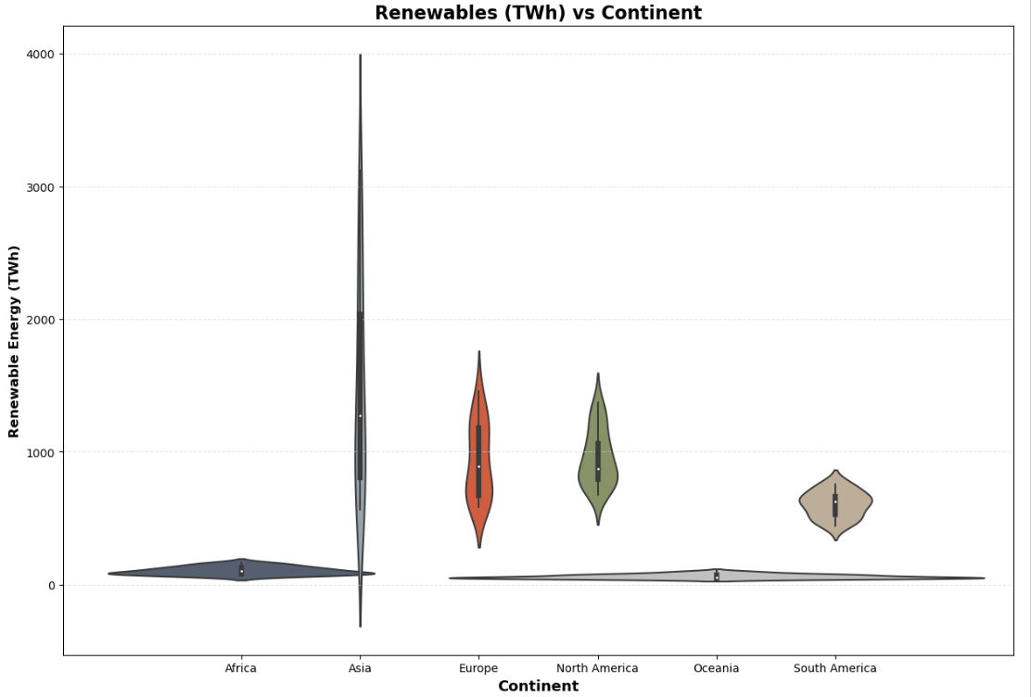

As can be seen by statistical analysis Asia has mean of @1500Twh followed by Europe & North America @900Twh and Oceania the lowest 60TWh installed renewable energy capacity.

Financial Flows by Continent

1. Asia and Africa received about 80% of funding.
2. India and Pakistan received maximum funding in Asia. Ethiopia and Nigeria received more funding in Africa.
3. As a result Asia & Africa’s installed Renewable energy capacity increased by about 5 and 3 times respectively.

The donut chart shows that Asia and Africa received about 80% of funding. India and Pakistan received maximum funding in Asia, while Ethiopia and Nigeria received more funding in Africa. As a result, Asia & Africa’s installed Renewable energy capacity increased by about 5 and 3 times respectively. This contradicts the micro level analysis we discussed earlier. By looking at it from higher level /continent level it can concluded that the financial funding has helped developing countries to move towards renewable energy.

Overall Energy and Financial Flows by Continent

So far we have discussed in terms of % & statistical data, table below shows absolute data comparing year 2000/2010/2019 by continent. It can be concluded from table -

1. Nuclear energy has not change for most part because of risk associated with the technology
2. By focusing on Africa and Asia if Renewable energy was not considered this would have resulted in @30% increase in C02 emission in Asia and @25% in Africa assuming linear relationship between CO2 emission and installed electricity by fossil energy
3. Point worth noting here is access to electricity (col 5)  shows @50% of Africa still do not have access to electricity some of this can possibly be offset by solar or wind

Bias and Limitations

1. Renewables are impacted by a number of socio-economic factors that this data set would be unable to capture
2. Did not include all countries in the world (148 / 195)
3. The guidelines defining the developed and developing countries should be included Outside factors of renewable investments limitations in supply chain and delayed outcomes of financial flows.
4. A breakdown of the types of renewable energy is missing . this will help to show concentration of wind/solar/hydro and other form of energy